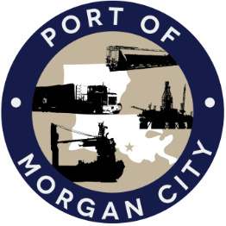

AGENDA

MORGAN CITY HARBOR AND TERMINAL DISTRICT
Regular Meeting of August 13, 2018 – 5:00 p.m. – 7327 Highway 182

1. Call to Order and Roll Call

2. Invocation and Pledge of Allegiance

3. Minutes
A. Regular Meeting of July 9, 2018

4. Finance Report
A. Presentation and discussion of financial reports for July 2018 – Deborah Garber
B. Invoices

5. Guest(s)/Public Comment
A. United States Coast Guard
B. Corps of Engineers, New Orleans District

6. Raymond “Mac” Wade - Executive Director’s Report
A. Consultant – Michael Knobloch, Knobloch Professional Services, LLC
B. Consultant – Clay Breaud, Providence/GSE
C. Consultant – Michael Lowe, GIS Engineering, LLC
D. Cindy Cutrera, Manager of Economic Development

7. Gerard Bourgeois - Legal Report

8. New Business
A. Discussion and any action regarding application to the Louisiana Port Priority Program for assistance in the implementation of a port improvement project for railroad spur and land improvements
B. Discussion and any action on facility security officer agreement with Lazer Claims Investigation & Security Services

9. Old Business
A. Discussion and any action on leasing, improvements, maintenance and repairs to facility(ies), including Coast Guard lease(s) and HVAC work
B. Discussion and any action regarding the U.S. Department of Homeland Security grant program, including request for proposals, bids, purchases, maintenance for equipment, software and NOAA ports system(s)
C. Discussion and any action on Government Operations and Emergency Center including bids, purchases, payments, leasing and Facility Planning and Control
D. Discussion and any action on Atchafalaya River Channel including dredging and sediment management, equipment purchases, reports, survey services, consulting services, economic study(ies), landowner agreements, cooperative agreement(s) with Brice Civil Contractors and the U.S. Army Corps of Engineers
E. Discussion and any action on Youngswood Site Development Project
F. Discussion and any action on Baker Hughes Oilfield Operations LLC facility leases or sublease

10. Election of officers – special

11. Adjournment

In accordance with the Americans with Disabilities Act, if you need special assistance, please contact Tori Henry at 985-384-0850, describing the assistance that is necessary.

